Interference Model for Change Detection Task

[Author Name(s), First M. Last, Omit Titles and Degrees]

[Institutional Affiliation(s)]

Author Note

[Include any grant/funding information and a complete correspondence address.]

Abstract

[The abstract should be one paragraph of between 150 and 250 words. It is not indented. Section titles, such as the word Abstract above, are not considered headings so they don’t use bold heading format. Instead, use the Section Title style. This style automatically starts your section on a new page, so you don’t have to add page breaks. Note that all of the styles for this template are available on the Home tab of the ribbon, in the Styles gallery.]

Keywords: [Click here to add keywords.]

Interference Model for Change Detection Task

Change-detection task is one of the commonly used paradigm in visual working memory study and is also responsible for the resurgence of the discrete slot theory for the visual working memory capacity. However, while there are many computational models built for continuous reproduction task, another commonly used paradigm in visual working memory, there are only few models designed for change-detection tasks. In this study, instead of creating the models of different theories explaining the working memory capacity, we adapted the models designed for continuous reproduction task to simulate the result of the change-detection task. There were some studies tried to adapt the models designed for the continuous reproduction task. Keshvari et al (2013) adapted Slot-Averaging model and the Variable-Precision model to change-detection task with Bayesian inference rule. However, the Interference Model came out after Keshvari (2013), which was not included in the model comparison. Also, in Keshvari (2013), the researchers compared the models with the full array change-detection task, which complicated the adaption process. In this study, we compare the IM together with the SA and the VP with single-probe change-detection task which is much similar to the continuous reproduction task.

The models included in the paper are the Slot-Averaging model, the Variable-Precision model, and the Interference Model. All the models are designed to simulate the continuous reproduction task, and each model represents different theory about the nature of the visual working memory capacity. The Slot-Averaging model assumed visual-working memory capacity as discrete slots, and a slot can only store one item or a chunk. Once all the slots are used up. The remaining items will not be remembered. In the continuous reproduction task, if the target is remembered in a slot, the target will be recalled with certain precision. If the target is not remembered, however, participant would have to guess. Besides the discrete state of remembering or forgetting, one additional assumption in the Slot-Averaging model is that an item can be stored in multiple slots if there are free slots available. When recalling the items stored in multiple slots, participant will retrieve the item from all the slots and respond the average of the retrieved memory, which increases the precision of recall. The Variable-Precision model assumed that visual working memory capacity as a continuous resource. The resource can be continuously divided into items, and the precision of the memory increases when more resource is poured into an item. Besides the continuous resource, Variable-Precision model also assumed that the resource is not evenly distribute among all the items, the amount of resource allocated also varies from trials to trials, hence, the precision of memory varies from trials to trials. The Interference Model assumed that the cause of visual working memory capacity is interference between remembered items. While participant can remember unlimited number of items, items creates interference with each other, and the precision of recall decreases as result. The Interference Model assumed the recall process activates the response candidates (e.g., all the colors on the color wheel), and the response candidates compete with each other. The response candidate is more likely to be recalled with higher activation. The activation of the response candidates comes from three sources. First source is the context independent activation, which arises from the recent encountered items. Second source is the background noise, which arises from the noise during the encoding and retrieval process. The last source of activation is the context-based retrieval activation, which arises from using the context (e.g., location) to retrieve the bound content (e.g., color). In the Interference Model, the interference comes from the context independent activation and the context-based retrieval activation. The more items remembered in the memory, the items create more context independent activation. Also, the probability of activating the items bound to the other locations increases. Both leads to more interference from the non-target items. Also, in the IM, one item can be stored in the focus of attention, and said item has higher precision and is resistance from the interference of the other items.

To adapt the models designed for continuous reproduction task to single-probe change detection task, we implemented the similar Bayesian inference rule as in Keshivari (2013). While there are other methods to adapt a continuous reproduction model to change-detection task (e.g., the limited information rule in Donkin (2016)), the Bayesian inference rule requires no additional parameters, which should leave the models in most neutral state without introduction addition interaction between new parameters and original parameters.

The Bayesian inference rule assumed that participants tried to recall the target color at the probed location and evaluate the probability that the recalled color and the probe came from same condition and the probability that both came from change condition. The response is given to the higher probability condition, as

|  |  |
| --- | --- |
|  | (1) |

where the is the recalled color and is the probe color. If the logged ratio, , is larger than zero, the response will be *change*; otherwise the response will be *same*. With the help of Bayesian theorem, the Equation 1 can be rewritten as:

|  |  |
| --- | --- |
|  | (2) |

The values of and depend on the experiment design and were identical in this study, therefore both canceled out in the equation.

The next step is to determine the . Because the probe color is already determined, we only need to figure out what’s the probability of recalling when the was given in the *change* condition. We assumed that when in change condition, the probe color was selected randomly from all the possible colors on the colorwheel with equal probability. Since the recalled color will be center around the target color, and the target color and the probe color are not correlated at all. The recalled color will form a uniform distribution across all the colors on the colorwheel. Therefore the probability of recalling in the *change* condition is

|  |  |
| --- | --- |
|  | (1) |

As for the , since the probe condition is *same*, the probe color is assumed to be identical as the target color, the will be identical as the probability of recalling color at the target location, as:

|  |  |
| --- | --- |
|  | (1) |

The became

|  |  |
| --- | --- |
|  | (1) |

To determine the probability of change response, we simply integrate through all the , as

|  |  |
| --- | --- |
|  | (1) |

The advantage about using the Bayesian inference rule is that, as long as a model provides , the model can be adapted into single-probe change-detection task without additional parameter. However, the Bayesian inference rule assumed some certain probe scheme for *change* or *same* condition, which is not always in line with the typical probe scheme used in the change-detection task. Therefore, we conducted two versions of experiment with difference probe scheme and investigate how the probe scheme affects the result.

# Experiment A and B

The goal of Experiment A and B was to acquire the data for model comparison by using single-probe change-detection task. Because the Inference rule assumed a particular probe scheme, we tested two different probe schemes in the Experiment A and B. The probe selection scheme in Experiment A followed the assumption of the Inference rule, i.e., the probe color for *no change* condition was identical to the target color, and the probe color for the *change* condition was randomly choose from any color that is not the target color with equal probability. The probe scheme of Experiment B followed the traditional probe scheme for single-probe change-detection task. The probes from the *no change* condition are sampled around the target color, and the probes from the *change* condition are either sampled from the non-target colors or from the colors what are not around target and non-target colors.

## Method

### Participants

Experiment A and Experiment B both included twenty participants recruited from University of Zurich. Participants had normal or corrected-to-normal vision and no colorblind. Participants were rewarded with course credits or 60 Swiss Francs after completing the Experiment A and 45 Swiss Francs after completing Experiment B.

### Material

Color patches selected from a color wheel which was created in CIE L*a*b* color space with a radius of 60 and centered at luminance set to 70, *a* set to 20, and *b* set to 38. The minimum distance between selected colors is 1 degree. The stimuli were displayed in RGB value with Gamma correction for IEC 61966-2-1 standard.

### Procedure

Experiment A consisted of four identical sessions, and Experiment B consisted of three identical sessions. All the sessions were conducted at different days, and each session took about one hour to complete. Experiment A consists of xxx trials, and Experiment B consists of xxx trials. The procedure in the trials are identical for both Experiment A and B.

At the beginning of each trial, several color patches were displayed on the screen for 500ms, which was followed by a blank screen for 500ms. The number of color patches ranged from one to six. The locations of the color patches were randomly selected from 13 possible locations on an invisible circle which centered at the center of screen. After the blank screen, a probe was displayed on one of the stimuli locations, and empty frames were displayed on the rest of the stimuli locations. Participants were asked to judge if the probe is the same color as the color patches presented previously at the same location by pressing left mouse button for “same” or right mouse button for “change”. After participants made their response, a blank screen appeared for 500ms and was followed by the beginning of the next trial.

In Experiment A, the probe matched the target color in 50% of the trials. For the remaining 50% of the trial, the probe was selected randomly from any possible colors other than target color. In Experiment B, the probe color was selected within a boundary around the target color 50% of the trials. In 25% of the trials, the probe color was selected within a boundary around the non-target color. For the remainder of the trials, the probe color was selected from the colors not within the boundaries of the target color and non-target colors. The only exception was in set size 1, since there was no non-target item, the probe was either selected within the boundary around the target color in 50% of the trials or any other possible colors for the remainder 50% of the trial. The boundary for selecting the probe color around target and non-target colors varies according to the set size of the trial, which was b1, b2, b3, b4, b5, and b6 for set size one to six, respectively. The boundary was based on the response deviance observed from the continuous-reproduction task for other study (cite). The probe scheme for Experiment A and Experiment B are illustrated in Figure 1.

### Result

In order to bring the result of Experiment A in line with the result of Experiment B, we relabeled the probes in Experiment A in the similar fashion as Experiment B. The *same* probes stayed the same. The *change* probes were relabeled into *internal change* and *external change*, where the former was the probe was within the boundary of the non-target color, and the later was the probe not within the boundary of the non-target color. The boundary for relabeling the change probes was the same as the boundary in Experiment A.

After relabeling the probes, the Bayes factor suggests there is no difference between Experiments (BF01 = 6.28). Therefore, the following analysis will be conducted with both Experiment A and B collapse together. The Bayes factor shown evidence in supporting both the effect of set size and probe type (BF10 = 7.79e+41 and BF10 = 5.65e+18, respectively). Evidence also supporte3d the interaction between set size and the probe type (BF10 = 2.20e+54).

## Model Comparison

We fitted the Interference Model, Slot-averaging Model, and Variable Precision Model to the data with the Baysian Inference rule. The models were implemented in Python 3.6, and the parameters were estimated with evolution assimulating algorithm in SciPy (CITE). The goodness-of-fit of the model was calculated via -log-likelihood. To avoid local minimum, the fitting process was repeated 10 times with different starting values (automatically chosen by the evolution assimulating algorithm), and the best fitting result was reported. To balance the different number of parameters in the models, we used AIC and BIC to compare between models.

However, there are some rooms of interpretation in the Bayesian Inference rule, especially when regarding the discrete states in the model. In the IM, whether the Bayesian Inference rule has the knowledge of the target is in the focus of attention or not. If the target is in the focus of attention, the target would have higher precision and resistance to non-target interference, which generates different comparing to recall the items not in the focus of attention. Having the knowledge of the target item is in the focus of attention or not would affect which will be taking into the Bayesian Inference rule. We tested both versions of Bayesian inference rule. The one involved the knowledge of whether the current target is in the focus of attention or not performed better than the other model, and the following report was based on said version.

For the Slot-Averaging model, we tested two Bayesian inference rule with different level of knowledge. The first inference rule had the knowledge of the current target is in the memory or not. If the target is in the memory, the recalled color always come from the target color, i.e., the probability of guessing is zero. If the target is not in the memory, however, the inference rule can only guess with 0.5 probability of change response. The second inference rule assumed that the knowledge of whether the target is in the memory or not is not accessible for the inference rule, but only the general probability of recalling the target is available. The fitting result shown that the second inference rule performed way better than the first one, as shown in Figure x. Therefore, for the following comparison, we used the inference rule which doesn’t have the knowledge of whether the target item is remembered or not.

The model fittings are shown in Figure x. Overall, all the models were able to fit the similarity gradient effect and the set-size effect for the same probes. However, only the IM was able to predict the worse performance of the internal change probes comparing to the external change probe. The goodness-of-fit shown that IM is the best fitting model out of the three. On average, the IM won on the SA and the VP over xx and xx on AIC and xx and xx on BIC per participants, see Table x for the summary of the goodness of fits. The SA and the VP fitted the data poorly mostly due to failed to fit the worse performance of the internal change probes comparing to the performance of the external change probes, and the fitting algorithm had to compromise between the performance of the internal change probes and external change probes.

The failure of predicting the worse performance of the internal change probe is due to the lack of ability to recall around the non-target location. For both the SA and the VP, the non-targets were ignored while recalling the target. Hence, the internal change probes were treated in the same way as external change probes, which results in the same prediction for both internal and external change probes. The IM, however, assumed that non-targets caused interference for recalling the target (from both activation A and activation C). Some recall responses were centered around the non-target colors, which caused the worse performance of the internal change probes comparing to the external change probes.

To compensate the lack of ability to predict the non-target responses, we also fitted the variants of the SA and the VP which were able to predict the non-target response, namely: SA-Swap and VP-Binding. The SA-Swap assumes that the swap error occurs between remembered items, and the probability of making the swap error increases linearly with set sizes. VP-Binding assumed that the color-location binding information also remembered during the encoding and recognition process, and the location is used to retrieve the bound color. Please refer to Oberauer & Lin 2017 for more detail about the SA-Swap and VP-binding model.

Both SA-Swap and VP-binding were able to capture the general trend in the data, including the worse performance of the internal change probes. However, both AIC and BIC indicated that SA-Swap and VP-binding are inferior in compare to IM, as shown in Figure x.

## Conclusion and General Discussion

In this study, we tested the models from three different theories about visual working memory capacity on the single-probe change detection task. The Interference Model out performed both Slot-Averaging and the Variable-Precision model, even after we extended the SA and VP models to account for the non-target response we observed in the data. The IM still fits the data better.

Unlike in the continuous reproduction task whether the existence of the non-target response is ambiguous (cite), the non-target response is reliably observed in change-detection task (cites). The similar effect was also observed in verbal materials, namely the intrusion cost in the local-recognition task. More importantly, unlike in the continuous reproduction task where the non-target response can be explained as that participants failed to remember the target color and recalled the non-target color as one possible guessing response, the non-target response in the change-detection task can not be explained via guessing. If participant did not remember the target color but remembered the non-target color, and the non-target color shown up as a probe. The participant should reject the probe since the participant did remember where the non-target comes from, and we should observe the intrusion benefit. The non-target response can only be explained by either losing the location information or a swap error between the non-target and the target.

In the presented study, the slot averaging model failed to simulate the intrusion cost without including the swap error. Also, the probability of the swap error occurs has to increase with set sizes in order to simulate the observed intrusion cost. Donkin (2014) shown that the slot model with constant swap error would predict the decreasing of the intrusion cost, which contradicted to the finding in Donkin (2014) and in present study. However, with the assumption that the probability of swap error increases with set sizes, the SA model is able to simulate the intrusion cost we observed, although it is difficult to explain why the swap error would increase with set sizes, especially when the set size exceeds the capacity limit.

The Variable Precision model also can not simulate the intrusion cost without implementing the non-target response. Also, similar to the SA-swap where the probability of swap error increases with set sizes, the VP-binding also assumes that the probability of making the non-target response increases with set sizes. Every non-target item has equal probability of being recalled instead of the target because the expected value of the spatial distance between the target and non-target item is constant in our experiment design.

The different level of knowledge involved in the Bayesian inference rule shown both benefit and harm to the model fitting depending on the models. For IM, the knowledge of knowing if the target is in the focus of attention or not improved the model performance. However, the knowledge of an item is in the memory or not reduced the performance on the SA model. The detriment of the SA could be because that in the paper, the Bayesian inference rule does not include response bias. Both *same* and *change* are equally possible in the guessing state. Thus, the predicted performance for both *same* and *change* probes reduced when the set size increases. We didn’t include the response bias into the Bayesian inference rule because the inference rule without the knowledge of the memory state can still perform the task, and the response bias requires one additional parameter.

References

Last Name, F. M. (Year). Article Title. *Journal Title*, Pages From - To.

Last Name, F. M. (Year). *Book Title.* City Name: Publisher Name.

Tables

Table 1

[Table Title]

|  |  |  |  |  |
| --- | --- | --- | --- | --- |
| Column Head | Column Head | Column Head | Column Head | Column Head |
| Row Head | 123 | 123 | 123 | 123 |
| Row Head | 456 | 456 | 456 | 456 |
| Row Head | 789 | 789 | 789 | 789 |
| Row Head | 123 | 123 | 123 | 123 |
| Row Head | 456 | 456 | 456 | 456 |
| Row Head | 789 | 789 | 789 | 789 |

Note: [Place all tables for your paper in a tables section, following references (and, if applicable, footnotes). Start a new page for each table, include a table number and table title for each, as shown on this page. All explanatory text appears in a table note that follows the table, such as this one. Use the Table/Figure style, available on the Home tab, in the Styles gallery, to get the spacing between table and note. Tables in APA format can use single or 1.5 line spacing. Include a heading for every row and column, even if the content seems obvious. A default table style has been setup for this template that fits APA guidelines. To insert a table, on the Insert tab, click Table.]

Figures

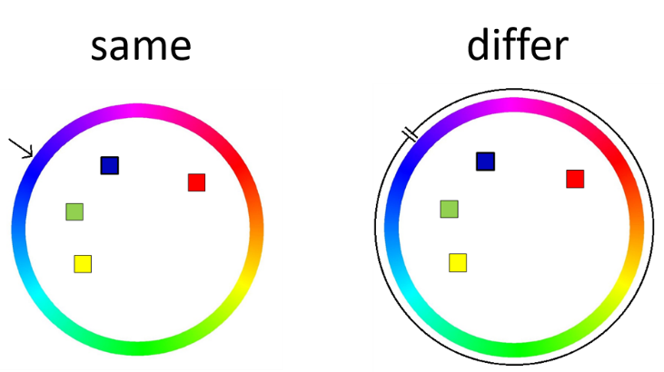 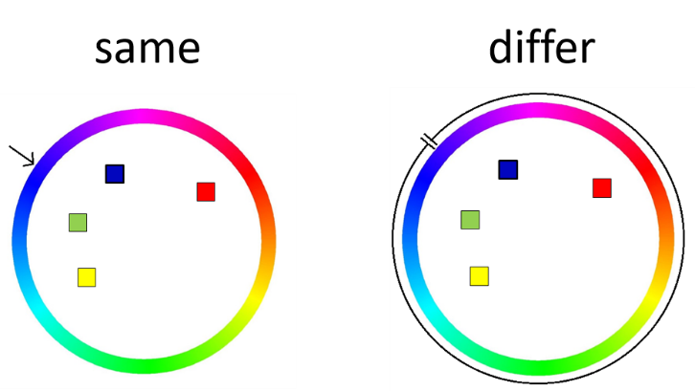

Change

Same

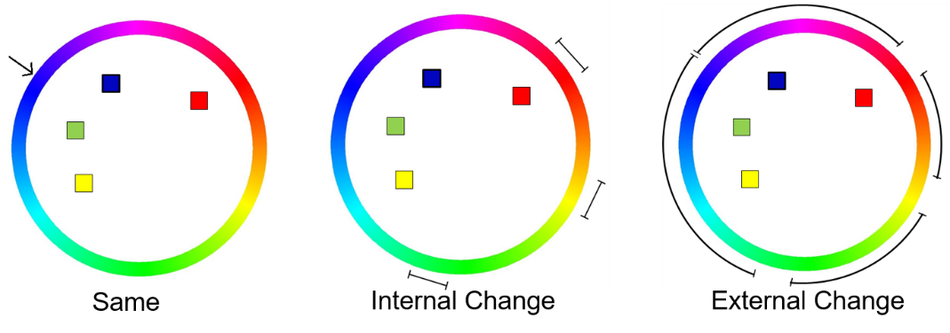

Figure 1. The probe scheme for Experiment A and the Experiment B. The four colors used in the trials are blue, red, green, and yellow, and the probe is presented at the blue color location. The top row is the probe scheme for Experiment A, and the bottom row is the probe scheme of Experiment B.

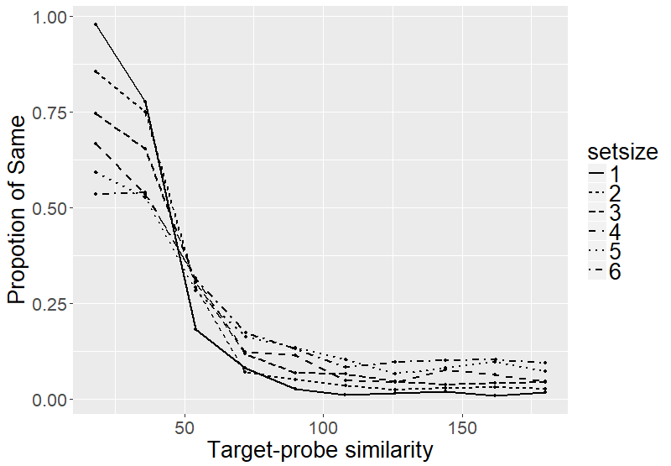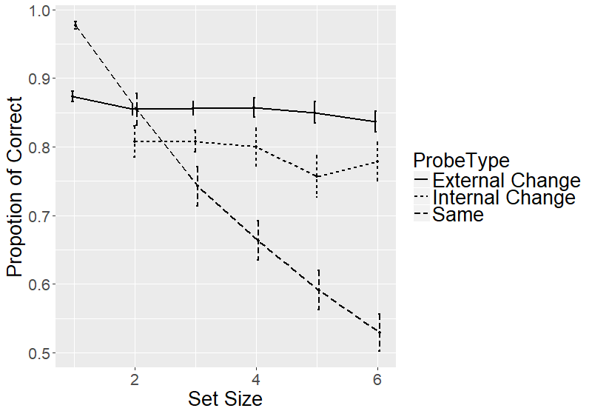

Figure 1. The response distribution and the Proportion of Correct from the collapsed result of Experiment A and B.

Figures title:

Figure 1. [Include all figures in their own section, following references (and footnotes and tables, if applicable). Include a numbered caption for each figure. Use the Table/Figure style for easy spacing between figure and caption.]

For more information about all elements of APA formatting, please consult the APA Style Manual, 6th Edition.